

PRODUCTS LIST / CATALOGUE
MEDICAL
S.NO | ITEM | TECHNICAL  EXPLANATION | REMARKS | IMAGES WITH  PACKING | IMAGES OF  PRODUCTS
1 | SURGICAL COTTON ABSORBANT , BLEACHED, UNBLEACHED | Rolled surgical cottons  Size Available: Rolls of (10g), (25g), (50g), (100g), (300g), (500kg) or  custom sizes.  sterilization: gama radiation or EO - sterilization | Packing: wrapped in moisture- proof paper.  Need to confirm th size | 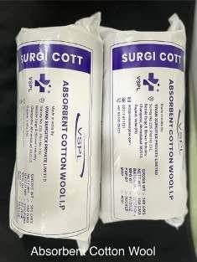 | 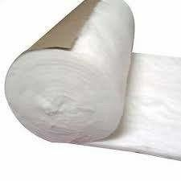
2 | BANDAGE GAUGE CLOTH | Material used: cotton gauze  Size Available: Rolls of (5cm x 3m), (7.5cm x 3m), (10cm x 3m), (15cm x 3m)  sterilization: gama radiation or EO - sterilization | Packing: EO sterilaziation compactable pouches or flow wrapping or wrapped with Medical grade wrapper.  Need to confirm the type and Size. | 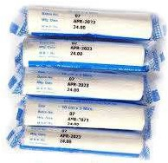 | 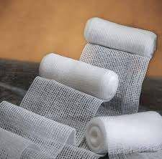
3 | STERILE DRESSING PAD - (ETO & UV) | Outer Layer: cotton gauze Inner Layer: absorbant cotton Size Available: Rolls of (5cm x 5cm), (10cm x 10cm), (10cm x 15cm),  (15cm x 20cm).  Sterilization: Ethylene Oxide (ETO) and UV | packing: 4 side sealing pack or Blister packing or EO sterilaziation compactable Pouches.  Need to confirm the type and Size. | 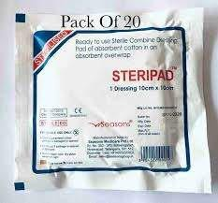 | 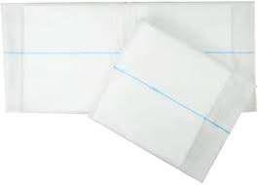

4 | GAUGE SWAB | Types: 1) Amaricn fold 2) French fold .  Types of folds: 8, 12, 16 fold.  Size avilable : 5 cm x 5 cm , 7.5 cm x 7.5 cm and 10 cm x 10 cm | We need to choose the type and number of fold. | 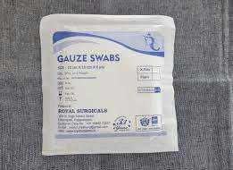 | 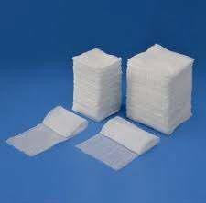
5 | ABDOMINAL MOPPING PAD ( 30 CM  X 30 CM ) | Size avilable :30 cm x 30 cm with X-ray dedectable thread  No of ply : 8 ply,12 ply,16 ply avilable | Need to choos the number of plys . | 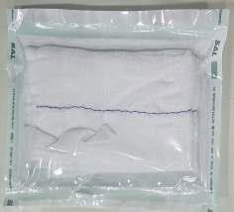 | 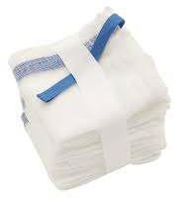
6 | CHLORHEXIDINE  GAUGE DRESSING (10X30 CM),(10X10 CM ) | Size avilable :(10 cm X 30 cm),(10  cm X10 cm ) Gauge cloth coated with  CHLORHEXIDINE sandvitched inbetween two oil  papers are ready to use.  Either gama radiation or EO - sterilization | Packed in Aluminium foil 4 side  seal. | 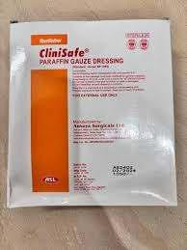 | 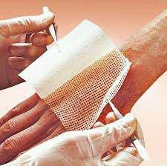

7 | COMBINE DRESSING PAD (VISCOS FABRIC) | Absorbant cotton will be kept inside a folded viscos cloth and two  sides will be sealed, so no cotton will be exposed out.  Outer Layer: Non-woven viscose fabric  Inner Layer: absorbent cotton  Size Available: (10 cm x 10 cm), (10  cm x 20 cm), ( 15 cm x 20 cm),( 20 cm x 40 cm)  Sterilization: EO gas, gamma radiation | packing: peelable foil pouches 4 side seal or Blister packing or EO sterilaziation compactable Pouches.  we can use Viscose cloth or Gauze cloth for the outer layer. Need to confirm the type | 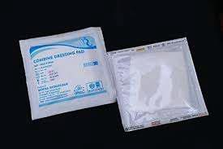 | 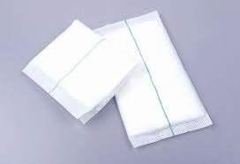
8 | ABSORBANT  COMBINE DRESSING PAD | Outer layer: Non-woven fabric or  cotton gauze  Inner layer: Absorbant cotton size avilable:(10 cm x 10 cm), (10  cm x 20 cm), (15 cm x 20 cm), (20 cm x 40 cm)  sterilization: gama radiation or EO - sterilization | packing: peelable aluminium  foil pouches 4 side seal or Blister packing or EO sterilization compactable pouchesand.  need to confirm the type | 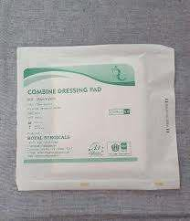 | 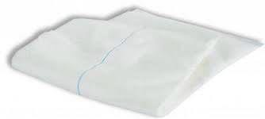
9 | PARAFFIN GAUGE DRESSING 10X10 CM | Material used: Open-weave cotton gauze impregnated with soft Paraffin.  Size Available:5 cmx5 cm, 10 cmx10 cm, 10 cmx20 cm  sterilization: gama radiation or EO - sterilization | Packing: Packed in Aluminium foil 4 side seal or EO sterilaziation compactable Pouches.  Need to confirm the size and Type. | 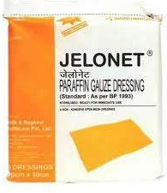 | 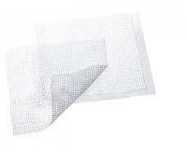

10 | POLYTHEN WATER PROOF WOUND DRESSING | Outer Layer: Transparent polyethylen film (waterproof and Breathable).  Inner Layer: absorbent cotton  Size Available: (5cm x 5 cm), (10cm x 10 cm), (10cm x 15 cm), (15cm x 20 cm)  sterilization: gama radiation or EO - sterilization | packing: EO sterilaziation Compactable pouches.  Need to confirm the type and Size. | 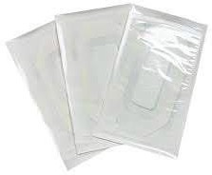 | 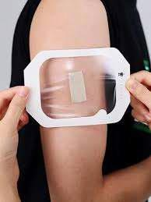
11 | SANITARY  NAPKIN( UV ) | Outer Layer: non-woven fabric  Absorbent Core: Superabsorbent polymer (SAP) and cellulose fluff Back Layer: Waterproof polyethylene (PE) film to prevent leakage.  Size avilable : (S) 24 cm, (M) 28 cm,  (L) 30 cm, (XL) 35 cm, (XXL) 40  cm,  12(XXXL) 45 cm.  Sterilization: UV Sterilization | Packing: Individually wrapped  in peelable wrapper.  Need to confirm the type and size. | 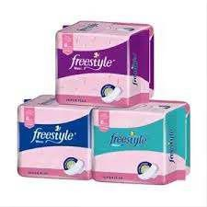 | 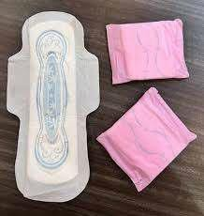
12 | MATERNITY PADS | Outer Layer:non-woven fabric Absorbent Core: Superabsorbent polymer (SAP) and cellulous fluff designed to handle post-partum flow.  Back Layer: Waterproof polyethylene (PE) film to prevent leakage and  ensure protection. Size Available:  Standard: (30 cm), (35 cm), (40 cm) Extra Large: (45 cm)  Sterilization: UV Sterilization | Packing: Individually wrapped in peelable wrapper.  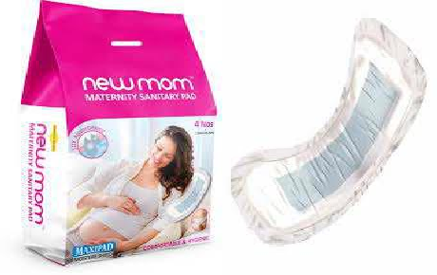  Need to confirm the type and size.

13 | COSMETIC BALLS | Material used : Absorbant cotton Size Available: (3 cm), (4 cm), (5 cm)  Sterilization: UV or gamma radiation | Packing:  Individually packed in plastic or pouches for hygiene (or)  Bulk packed in bags or cartons containing 100, 200, or 500 balls.  Need to confirm the type and size. | 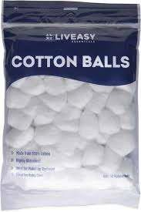 | 
14 | ADULT DIAPER | Outer Layer: non-woven fabric  Absorbent Core: Superabsorbent polymer (SAP) and cellulose fluff Back Layer: Waterproof polyethylene (PE) film  Size Available:  S: (50 cm – 70 cm waist) M: (70 cm – 90 cm waist) L: (90 cm – 110 cm waist)  XL: (110 cm – 130 cm waist) XXL: (130 cm – 150 cm waist) | Packing:  Individually wrapped in hygienic, peelable pouches. Bulk packed in cartons and PU packs typically with 10, 20, or 30 pieces per pack.Need to confirm the size. | 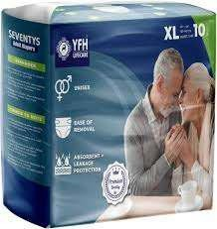 | 